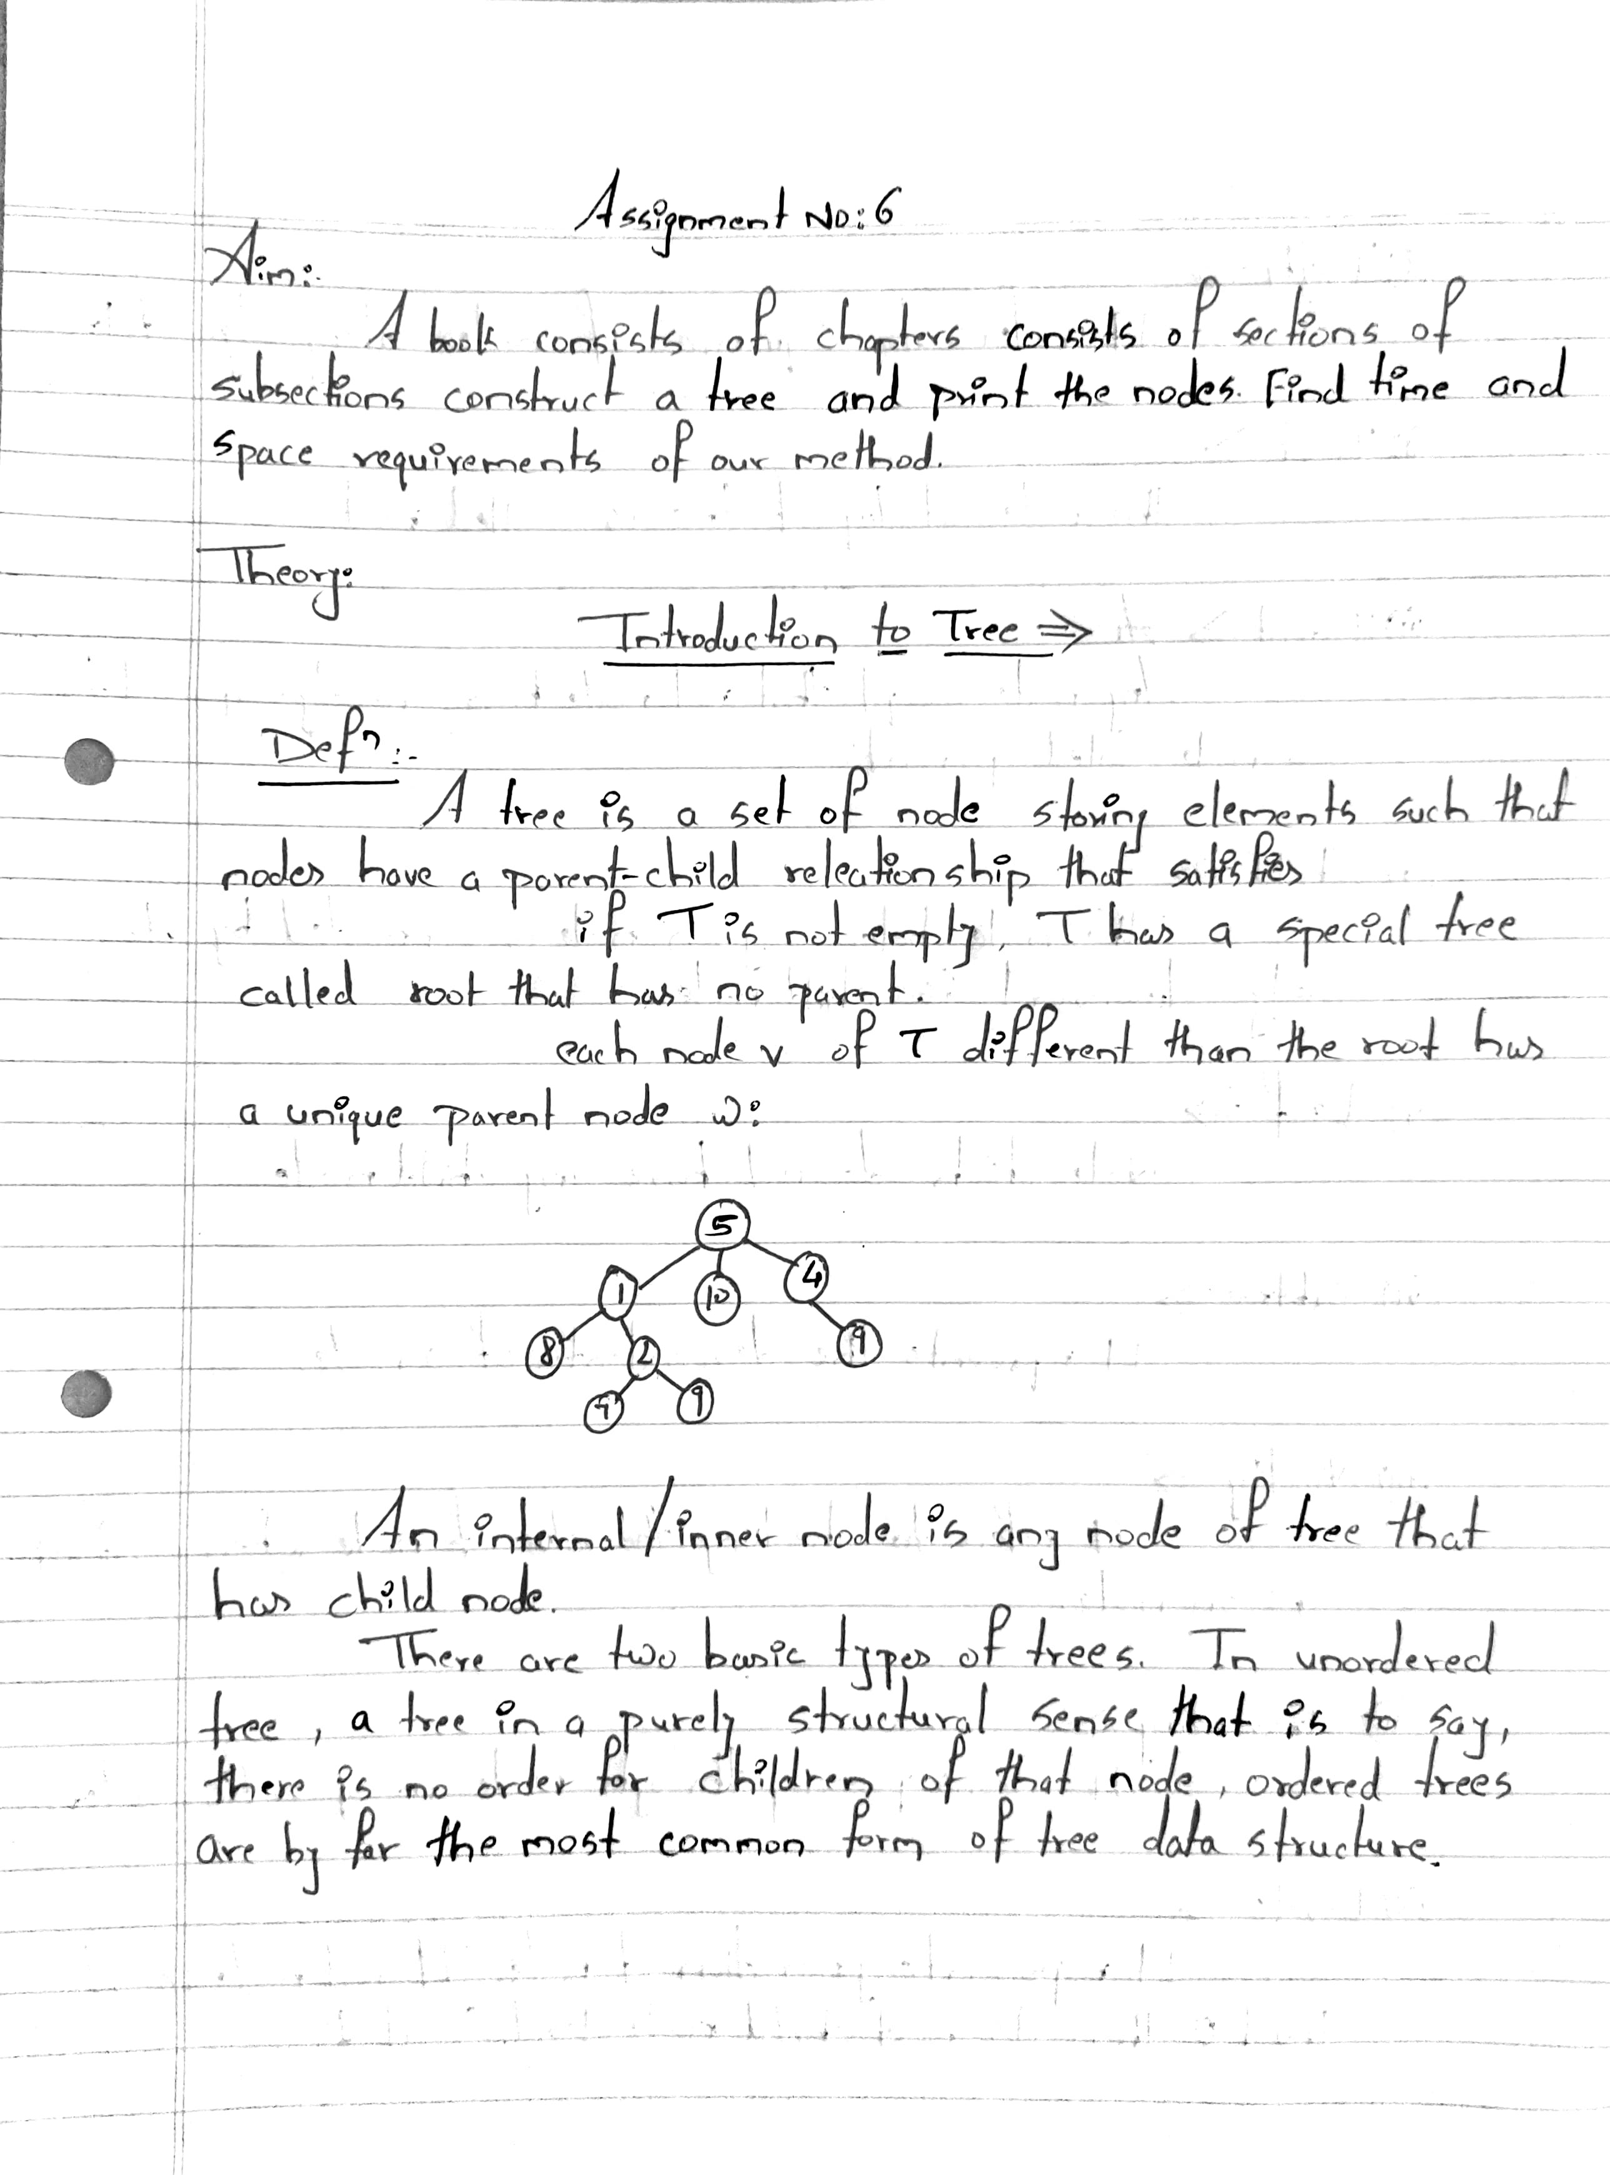

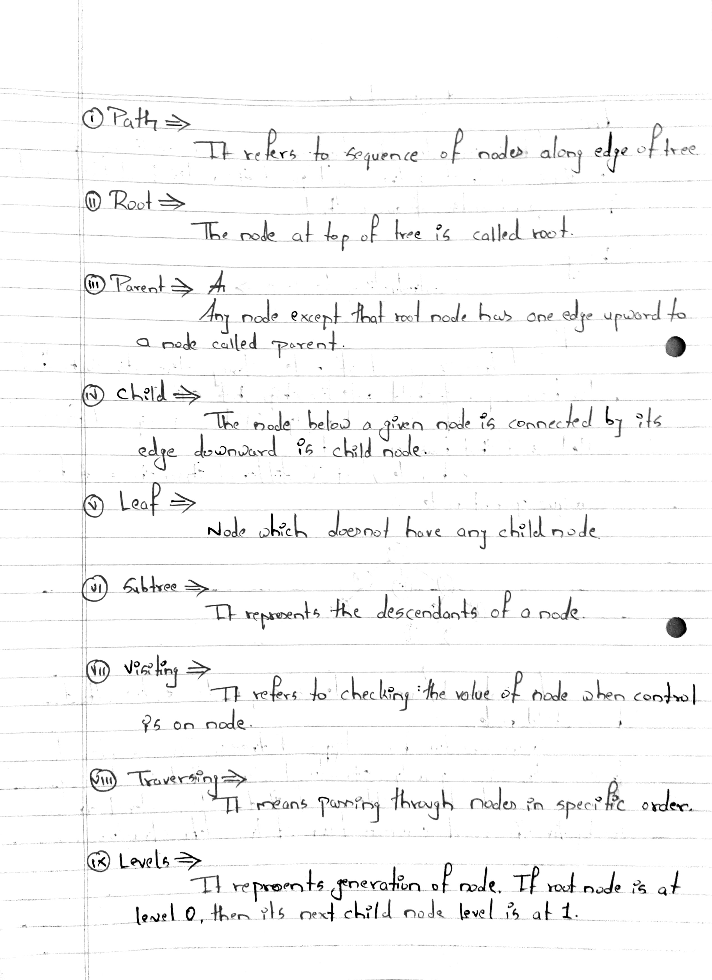

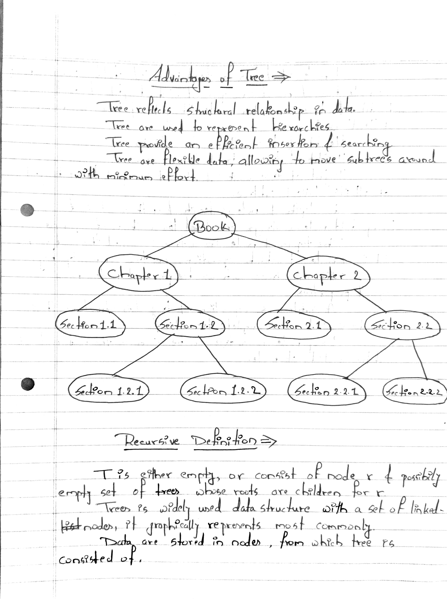

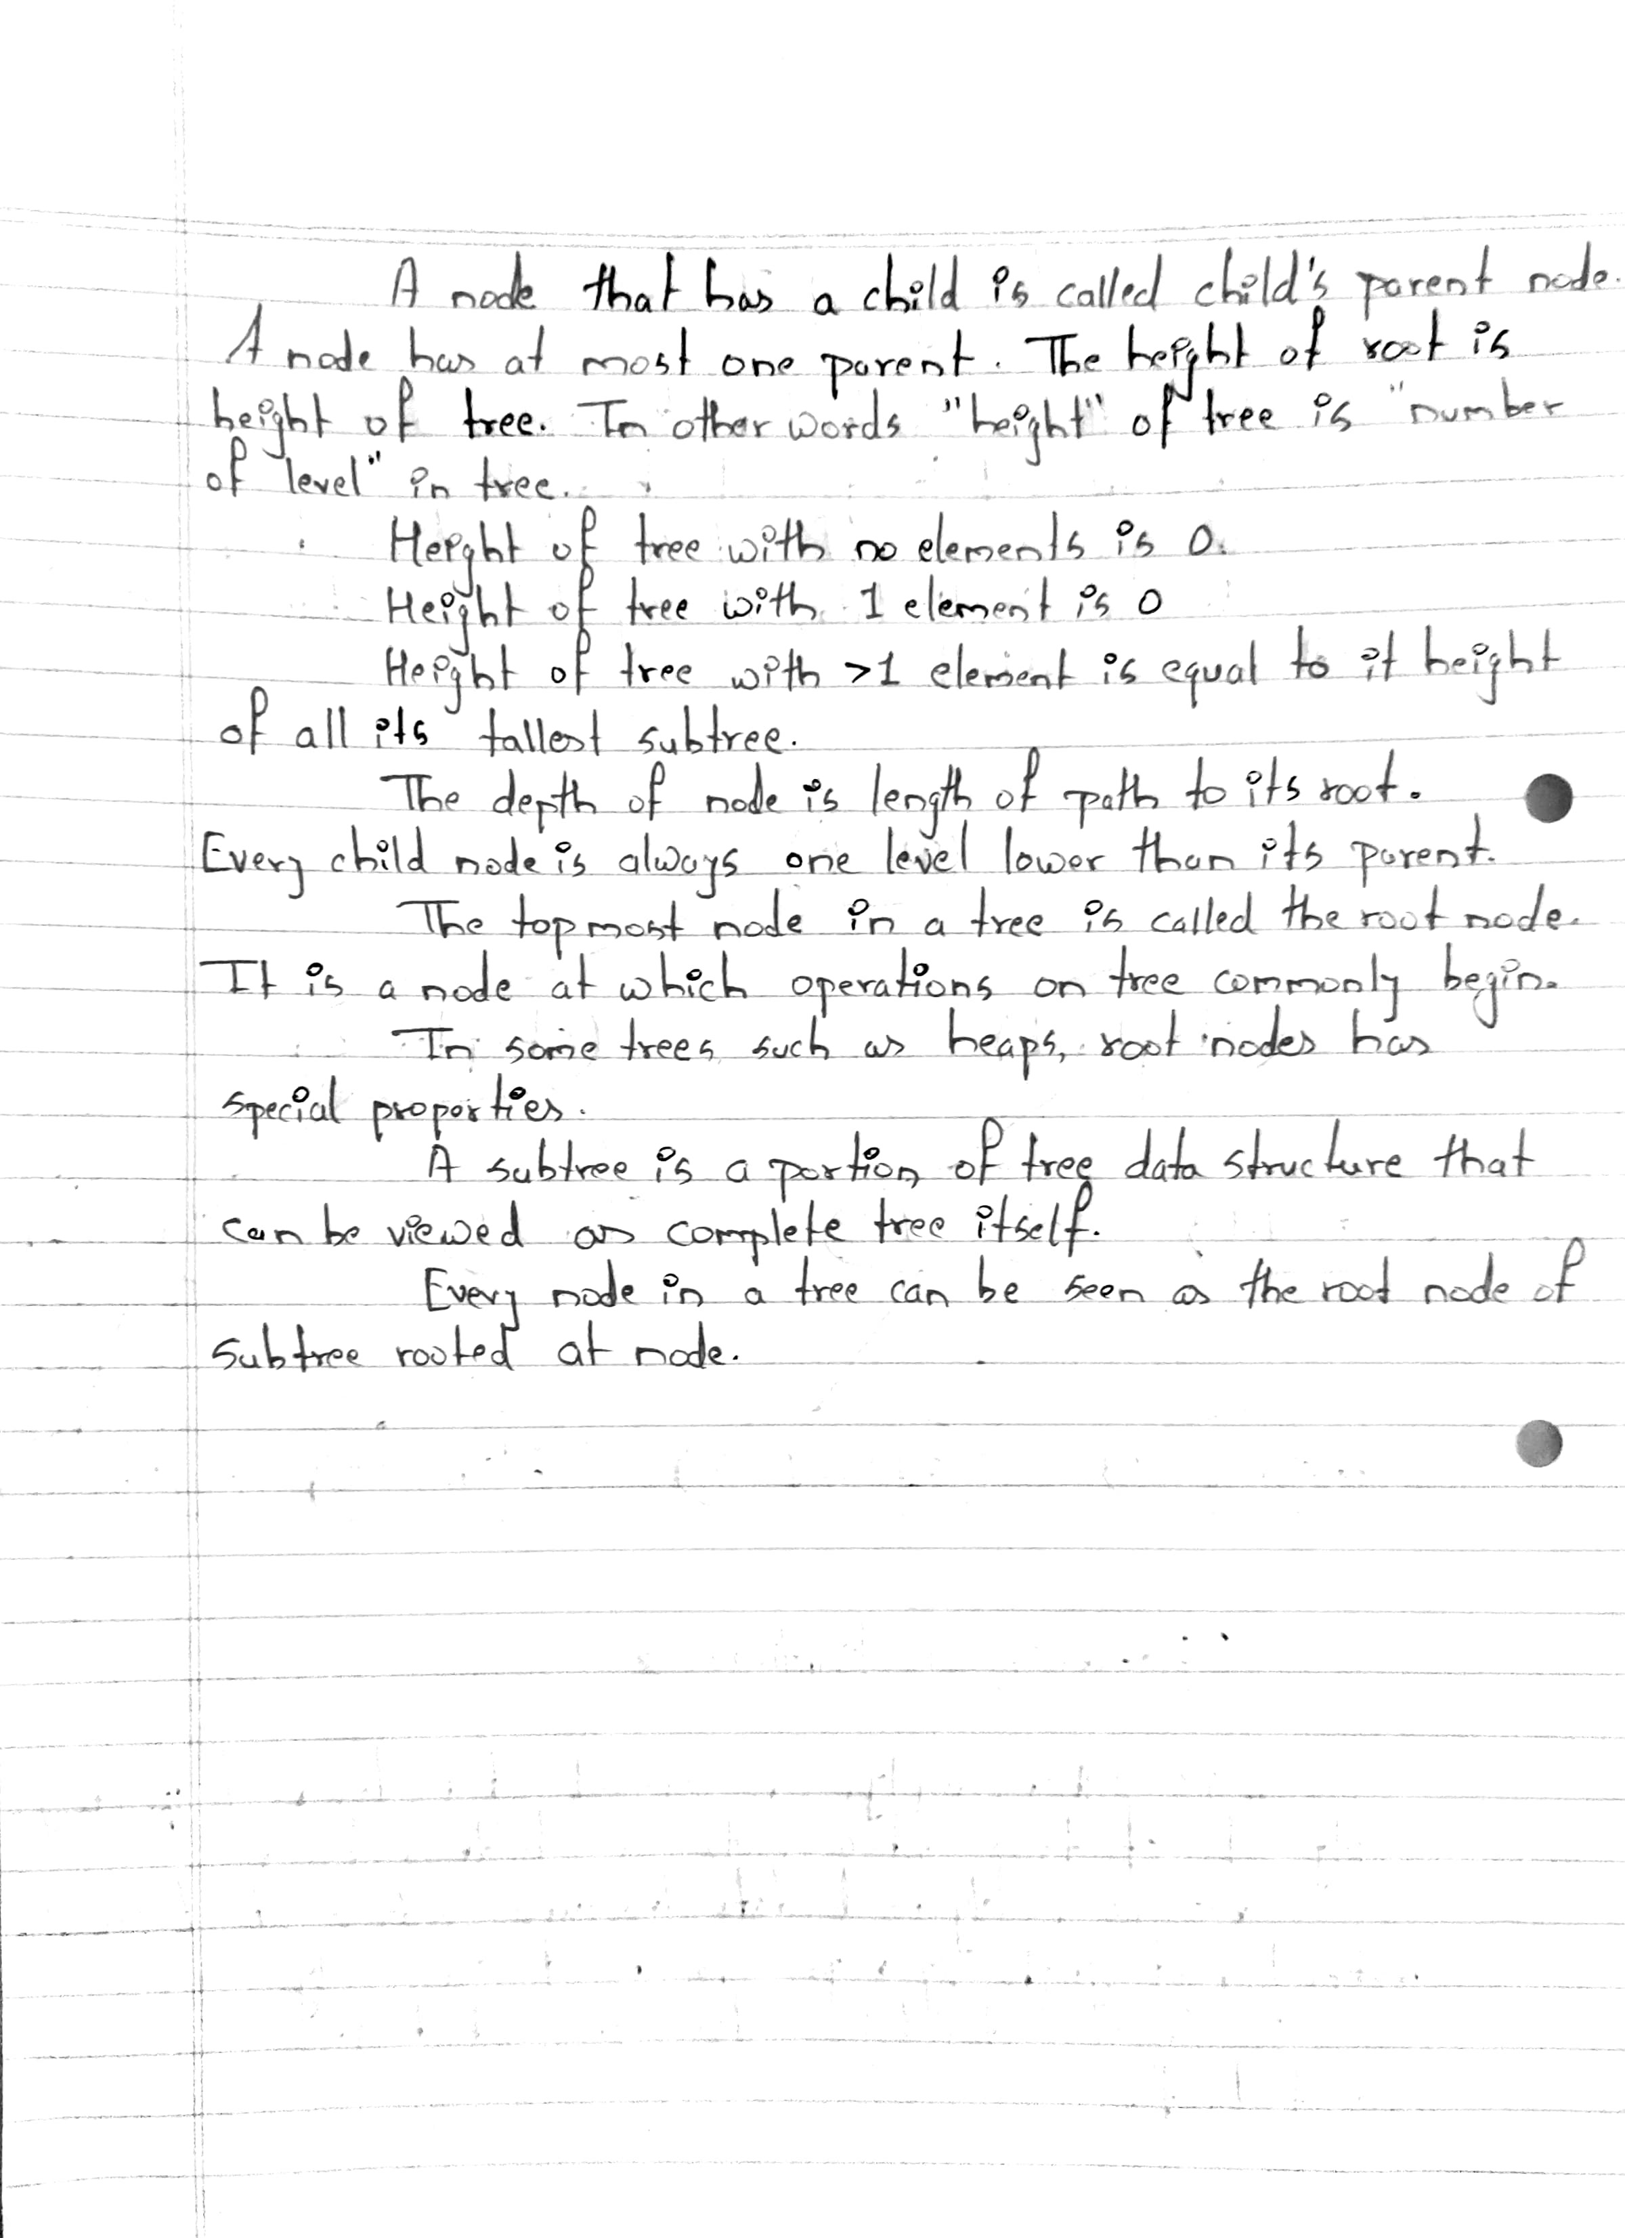

**Program Code:-**

//Program to illustrate double ended queue using array.

#include<iostream>

using namespace std;

#define SIZE 5

class dequeue

{

int a[10],front,rear,count;

public:

dequeue();

void add_at_beg(int);

void add_at_end(int);

void delete_fr_front();

void delete_fr_rear();

void display();

};

dequeue::dequeue()

{

front=-1;

rear=-1;

count=0;

}

void dequeue::add_at_beg(int item)

{

int i;

if(front==-1)

{

front++;

rear++;

a[rear]=item;

count++;

}

else if(rear>=SIZE-1)

{

cout<<"\nInsertion is not possible,overflow!!!!";

}

else

{

for(i=count;i>=0;i--)

{

a[i]=a[i-1];

}

a[i]=item;

count++;

rear++;

}

}

void dequeue::add_at_end(int item)

{

if(front==-1)

{

front++;

rear++;

a[rear]=item;

count++;

}

else if(rear>=SIZE-1)

{

cout<<"\nInsertion is not possible,overflow!!!";

return;

}

else

{

a[++rear]=item;

}

}

void dequeue::display()

{

for(int i=front;i<=rear;i++)

{

cout<<a[i]<<" "; }

}

void dequeue::delete_fr_front()

{

if(front==-1)

{

cout<<"Deletion is not possible:: Dequeue is empty";

return;

}

else

{

if(front==rear)

{

front=rear=-1;

return;

}

cout<<"The deleted element is "<<a[front];

front=front+1;

}

}

void dequeue::delete_fr_rear()

{

if(front==-1)

{

cout<<"Deletion is not possible:Dequeue is empty";

return;

}

else

{

if(front==rear)

{

front=rear=-1;

}

cout<<"The deleted element is "<< a[rear];

rear=rear-1;

}

}

int main()

{

int c,item;

dequeue d1;

do

{

cout<<"\n\n****DEQUEUE OPERATION****\n";

cout<<"\n1-Insert at beginning";

cout<<"\n2-Insert at end";

cout<<"\n3_Display";

cout<<"\n4_Deletion from front";

cout<<"\n5-Deletion from rear";

cout<<"\n6_Exit";

cout<<"\nEnter your choice<1-4>:";

cin>>c;

switch(c)

{

case 1:

cout<<"Enter the element to be inserted:";

cin>>item;

d1.add_at_beg(item);

break;

case 2:

cout<<"Enter the element to be inserted:";

cin>>item;

d1.add_at_end(item);

break;

case 3:

d1.display();

break;

case 4:

d1.delete_fr_front();

break;

case 5:

d1.delete_fr_rear();

break;

case 6:

exit(1);

break;

default:

cout<<"Invalid choice";

break;

}

}while(c!=7);

return 0;

}

**Program Output :-**

